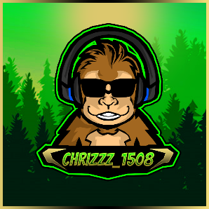Pokemon and Friends Mod (LB2)

Created By: chrizzz_1508

Version: 1.0

___________________________________________________________________________________________

Table of contents

Description 3

New Features 3

Requirements 4

OBS 4

Lioranboard 4

Other 4

Installation 5

Important notes about the installation 5

Creating a discord webhook (optional) 5

1. Deleting the existing Stuff 5

2. Install OBS Plugins 5

3. Install / Configure Lioranboard 2 6

4. Install the PaF Game 9

Functions 13

Spawn Mechanic 13

Runaway Mechanic 13

Catch Mechanic 13

Broadcaster Commands 14

Viewer Commands 14

Channel Point Rewards 15

Changing Settings 16

Potential Fixes 17

General: 17

Discord webhook not working: 17

Profile Pictures not working in the Catch Screenshot: 17

Gifs not showing: 17

Special Thanks to some awesome People 18

Final notes 18

Support me 19

# Description

This mod is based on the classic Pokemon and Friends Game for LB1 from the StreamUP Team.

# New Features

- HD graphics / GIF’s (a few GIFs are missing or have bad quality)

- Support for all 905 Pokémon + regional forms (+53) (Normal & Shiny)

- **Pokeball**, **Greatball**, **Ultraball** and **Masterball** as separate channel point rewards

- **Mystery Pokemon** / **Mystery Shiny** Channel Point Rewards to summon a random Pokémon / Shiny

- **Summon Pokemon** Reward to summon a Pokémon of the viewer’s choice

- **Give a Gift** Channel Point Reward to reduce the current runaway rate

- New Commands (**!catchrate**, **!escaperate**, **!mypokemon (en/de/fr)**, **!top10 / !top10shiny**, **!rank**, **!summon *, !summonshiny \***, **!poke-stop**, **!bonustime**, **!trainers**, **!settrainer**)

- Change of the spawn & runaway mechanic

- Customizable loading screen / loading animation when a new Pokémon spawns

- Customizable Shiny wallpapers

- Customizable spawn sounds

- Discord webhook to post / check the caught Pokémon

- Automatic refund if a player already caught a Pokémon

- Multi language support (German, English and French)

- Priority Catch (If someone summons a Pokémon, he/she gets a free random ball)

- Bonus time (Raids & Hosts boost the spawn-, catch- and shiny rate for X min)

- Queue system to give slower viewers a fair chance

- Pokémon Trainer feature (Viewers can set their own custom trainer avatar)

- Automatic Backup of the Trainer.ini

- For the first time, this also supports a Non-Affiliate version that works with chat commands instead of channel points

- Small easter egg (can you find it?)

- **Settings all in one place!** Change the game to best suit your channel!

# Requirements

In order to install this project, you must have the following software installed properly. Please refer to the installation guide/steps that are provided by the creators of the software.

OBS

[OBS Studio](https://obsproject.com/)

[OBS WebSocket - OBS Plugin](https://obsproject.com/forum/resources/obs-websocket-remote-control-obs-studio-from-websockets.466/)

[Move Transition - OBS Plugin](https://obsproject.com/forum/resources/move-transition.913/)

[StreamFX - OBS Plugin](https://github.com/Xaymar/obs-StreamFX/releases/)

Lioranboard

[LioranBoard - 2.06.03](https://obsproject.com/forum/resources/lioranboard-stream-deck-animator.862/) or newer

Other

[Maximum of 42 Channel Point Rewards](https://link.twitch.tv/myChannelPoints) (this app needs to be able to create up to 8 new rewards)

[.Net Framework 3.5](https://www.microsoft.com/en-us/download/details.aspx?id=21)

[Pokémon Font](https://github.com/PascalPixel/pokemon-font/tree/master/fonts)¹

¹ Install the font while OBS is closed. If you install fonts while OBS is open it won't recognize it until you re-launch OBS.

# Installation

## **Important notes about the installation**

Do NOT create Channel Points rewards yourself in Twitch, these rewards are created  
automatically in the installation process.  
If this doesn't work, try deleting the existing ones and run the **!poke-install** command again.

Feel free to customize the color, picture, description, and even the reward cost.

The name can only be adjusted in the Mod Installer before creating the channel points. If you want to change it later, you will have to adjust the triggers in the “**Pokemon and Friends Mod**” Deck as well.

## **Creating a discord webhook (optional)**

To create a discord webhook you need to go to your discord “***Server Settings***” 🡺 “***Integrations***” 🡺 “***Webhooks***” 🡺 “***Create a new webhook***” 🡺 And make sure to “***Save***” the webhook URL.

*This is necessary if you would like the game to automatically post your viewer’s Pokémon catches in Discord and the “***!mypokemon***” command to work properly.*

## **Deleting the existing Stuff**

* 1. Delete all existing Pokemon and Friends scenes from OBS
  2. Delete all exiting Channel Point Rewards
  3. Remove LB1 from OBS (delete the Dock / Browsersource)
  4. Restart OBS after you are done and leave it open

## **Install OBS Plugins**

* 1. Install the OBS Websocket Plugin (The ZIP Installation is recommended since the installer sometimes won’t work correctly)
  2. Install / update the Move Transition Plugin (The ZIP Installation is recommended since the installer sometimes won’t work correctly)
  3. Install StreamFX

## **Install / Configure Lioranboard 2**

* 1. Unzip Lioranboard 2 to a location where it can stay (you can’t move it easily later without screwing up a lot of things)
  2. Check the “***Allow Stream Deck and Transmitter***” Box in LB2 (in the settings menu)

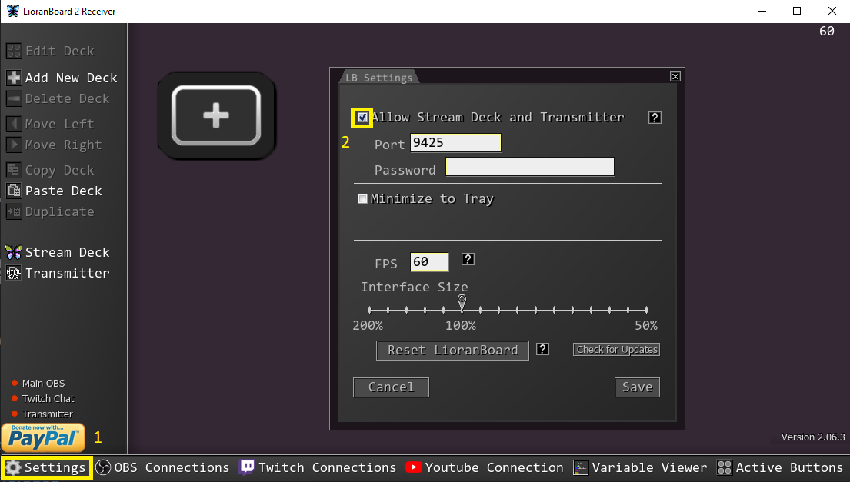

* 1. Linking your Twitch account and setting the correct scopes

To do this you will have to hit “***Twitch Connections***” 🡺 "***Edit Scopes***" 🡺 Check “***View Email address***” 🡺 “***Done***” 🡺 “***Open URL***”, it’s also recommended to select “***Auto connect to Twitch***”, if you did everything correctly, your account should now show up in LB2

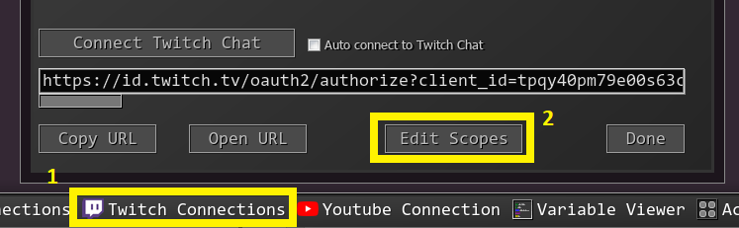

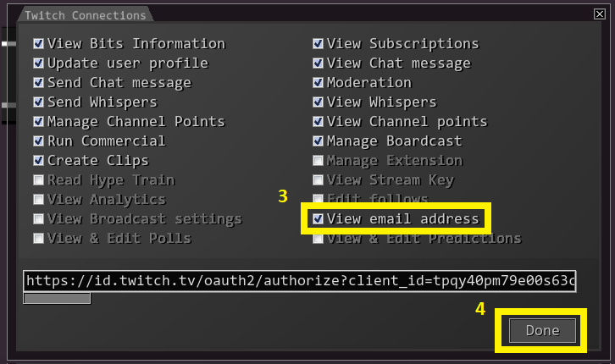

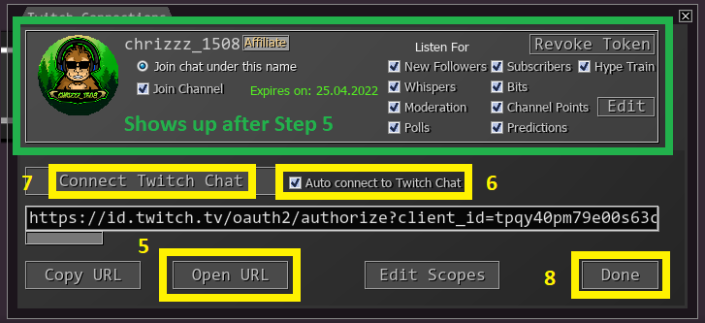

* 1. Adding the LB2 Transmitter to OBS as Dock

To add Lioranboard 2 to OBS you have to create a new Dock.  
You can do this by going to (“***View***”) 🡺 “***Docks***” 🡺 “***Custom Browser Dock***” and pointing the new Dock to the transmitter.html. It can be found in the Lioranboard2 🡺 Transmitter Folder

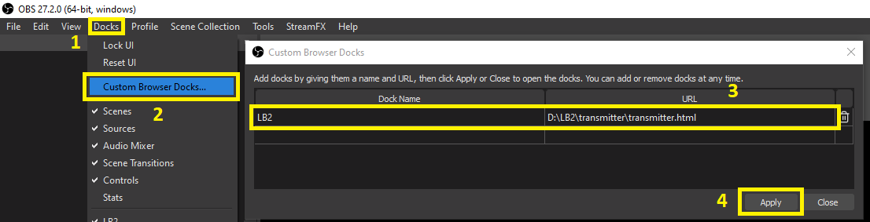

* 1. Connecting Lioranboard 2 with OBS

In LB2 go to “***OBS Settings***” and enter your OBS Websocket Settings.

These can be found in OBS under “***Tools***” 🡺 “***WebSockets Server Settings***”

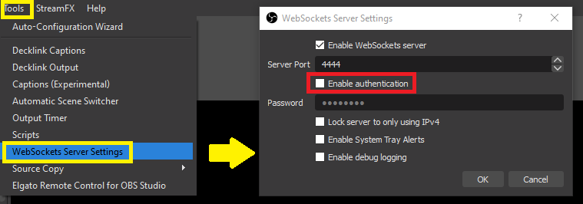

If you have the “***Enable authentication***” box checked, that means you will have a password enabled. If you can’t remember the password, you can either uncheck it or set a new password.

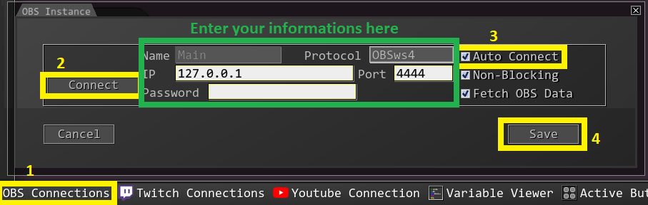

After you have entered your information hit connect (I also recommend checking the “***Auto connect***” box in LB2).

* 1. Check if everything is set correctly

If everything was set correctly, the 3 Green Lights on the left side of Lioranboard 2 and the 2 Lights in the new OBS Dock should be green. If they are not, try restarting OBS and LB2.

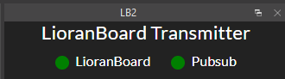 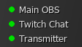

## **Install the PaF Game**

* 1. Run the PaF LB2 Mod program, fill out all fields and hit “***Install***”

If the installer won’t start because it’s getting recognized as a security threat, this has to do with it being not signed. In that case you might have to manually allow it to be run. To do this, first click “***More Info***” and then “***Run anyway***”

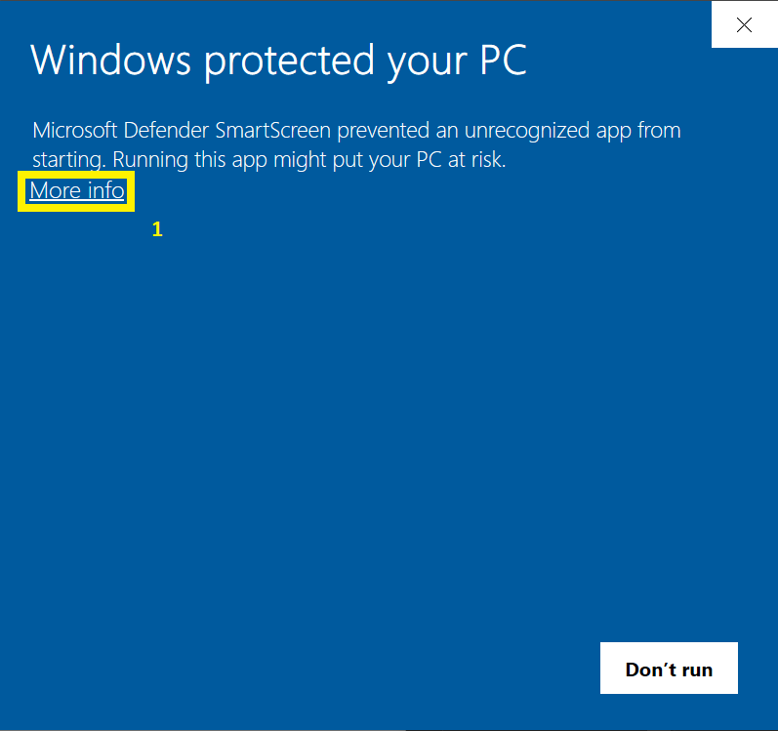

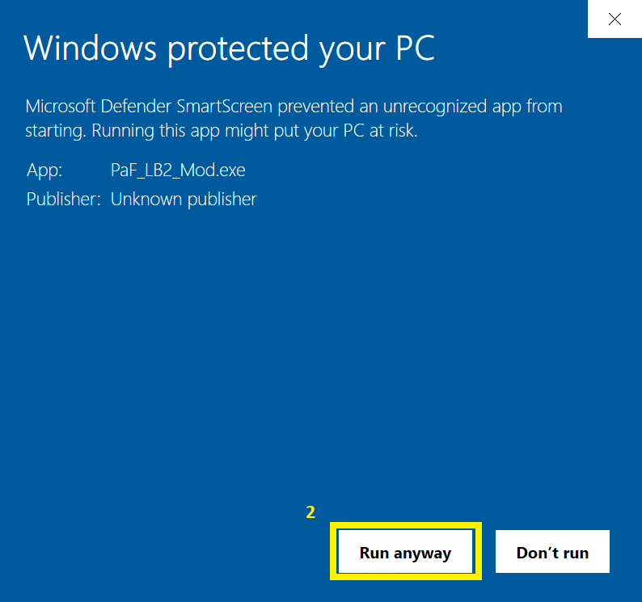

The complete code is available here so in case you think it might be malicious software please check it out:

https://github.com/Chrizzz-1508/Unofficial_Upgrader_for_the_PaF_Extension

The installer will create a new folder (**Pokemon and Friends**) with all necessary files in your LB2 Directory. If you are not sure what the settings mean, you can just hover with the mouse over a setting name and a small description will pop up.

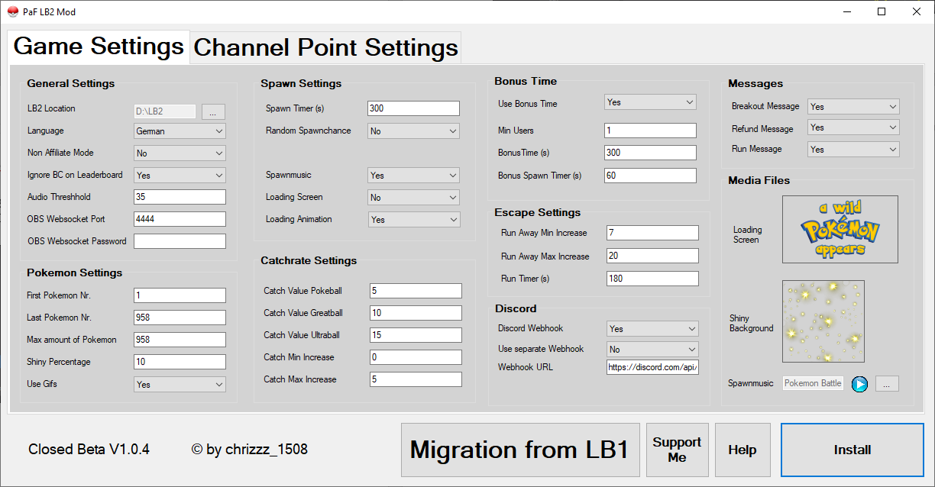

Ein Bild, das Tisch enthält.

* 1. Migrate over your process

If you want to carry over the progress of your viewers and the selected trainers from LB1 you will have to hit the “***Migration from LB1***” Button. This button will open a file selector where you will have to select your “***Pokemon_trainers.ini***” in the LB1 🡺 LioranBoard Receiver(PC) folder.

After you have selected the ini you will then have to select the LB2 directory and if everything is correct, a Message will pop up (this can’t be done manually since LB2 needs more parameters).

* 1. Install the PaF Extension

In Lioranboard 2 go on “***Transmitter***” 🡺 “***Install an Extension***” and select the “***PaFGame.lb2***” in your Lioranboard 2 🡺 Pokemon and Friends folder.

This will create a new deck in Lioranboard 2 called “**Pokemon and Friends Mod**”.

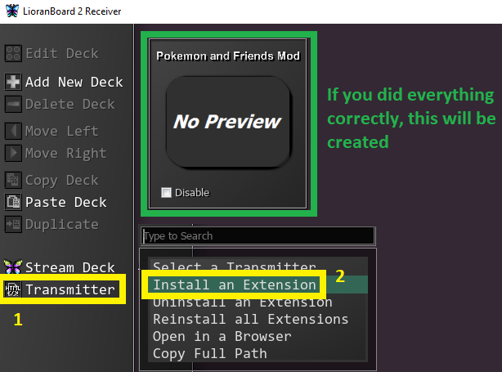

* 1. Create Channel Point Rewards and new Scenes

To create the Channel Point Rewards you can either restart Lioranboard2 or just type **!poke-install** into the chat.

The creation will take around 40-60 seconds and will be confirmed with a message at the end.

* 1. Add the game to your other scenes where you want to use it

To add the game to your existing scenes, just go to these scenes, select “Add source” and then select the “**PaF - Pokemon Scene**”. Feel free to resize it however you want to fit to your scene.

* 1. Adjust the channel point pictures (optional)

Go to your twitch dashboard and change the channel point reward pictures, some sample pictures are included in the installation folder.

# Functions

## **Spawn Mechanic**

The Spawn Mechanic has been updated in this version. As long as no Pokémon is currently on the screen, a timer is running in the background. After X amount of time has passed (default 5mins), a new Pokémon is spawned (the spawn can also be bound to a certain chance, so for example after 5min there will be 75% chance).

The viewers can also redeem Channel Point Rewards to immediately spawn a new Pokémon or the broadcaster can summon one with **!poke-start** / **!summon <number>** / **!summonshiny <number>**.

## **Runaway Mechanic**

For the runaway mechanic there are 2 new changes.

To avoid having a Pokémon stay on screen for too long, there is a timer running (default 3mins) in the background. This timer is reset whenever a ball is thrown. If there is no ball thrown or a “**Give a Gift**” reward is redeemed for the duration of the timer, the Pokémon will run away.

The 2nd change is about the Pokémon running away after it breaks out. In the original game this happens after 3 break outs. For this version a new variable called escape rate is used. Every time a Pokémon breaks out, this escape rate is increased by a random number between 2 values (default 7% and 20%). This value shows the chance of the Pokémon running away after a successful breakout.

The viewers can check the current escape rate with **!escaperate / !er** and use the “**Give a Gift**” Channel Point reward to reduce this chance back to 0%.

## **Catch Mechanic**

The viewers can check the catch rate of the current Pokémon with the **!catchrate** / **!cr** command. This command will show the catch rate for all 3 types of Pokéballs.

If a ball gets thrown, other viewers will have a 2s time window to redeem their balls, they then get queued up and the queue is emptied first before the rewards gets enabled again.

When a viewer tries to catch a Pokémon which they already have, or the Pokémon runs away while there are still balls in the queue, the channel points will be refunded automatically.

## **Broadcaster Commands**

**!poke-install** - Starts the Installation of the modified version

**!poke-init** - Resets the game and loads the settings / language keys (needed after changing the settings)

**!poke-start** - Spawn a new Pokémon manually

**!poke-end** - Reset/end the current catch game

**!summon \*** - Summons a specific Pokémon with the entered name / number name

**!summonshiny \*** - Summons a specific Shiny with the entered name / number

**!poke-stop** - Disables extension until the next **!poke-start** / **!poke-init**

**!bonustime** - Starts a bonus time with increased spawn, catch and shiny rate

## **Viewer Commands**

**!poke-commands** - Shows a list of the available commands

**!pokedex** - Shows information about the current on-screen Pokémon and if the user already caught it  
**!pokedex \*** - Shows information about the Pokémon and if the user already caught it, where **\*** refers to the Pokémon's name or Pokédex number

**!catchrate / !cr** - Shows the catch rate of the current Pokémon with all 3 types of Pokéballs

**!escaperate / !er** - Shows the current runaway chance of the Pokémon

**!top10** / **!top10shiny** - Shows the top 10 leaderboard

**!rank** - Shows the current rank

**!mypokemon** - Sends a list of the users Pokémon to the specified discord channel. ¹

**!credits** - Shows the creators

**!trainers** - Shows a list of available trainers

**!settrainer \*** - Changes the trainer to a certain sprite for that viewer

¹ This command requires discord webhook to be setup correctly. If you did not setup a discord webhook, you can edit the “***Settings***” button with your webhook information or re-run the installer to setup a webhook.

## **Channel Point Rewards**

**Pokeball** - Throws a Pokeball to try to catch the Pokémon (only available when a Pokémon is on screen)

**Greatball** - Throws a Greatball to try to catch the Pokémon (only available when a Pokémon is on screen)

**Ultraball** - Throws an Ultraball to try to catch the Pokémon (only available when a Pokémon is on screen)

**Masterball** - Throws a Masterball to catch the Pokémon. This ball has a 100% catch rate (only available when a Pokémon is on screen)

**Mystery Pokemon** - Spawns a new random Pokémon (only available when there currently is no Pokémon on screen)

**Mystery Shiny** - Spawns a new random Shiny (only available when there currently is no Pokémon on screen)

**Summon Pokemon** - Spawns a new specific Pokémon (only available when there currently is no Pokémon on screen)

**Give a Gift** - Resets the escape rate of the current Pokémon back to 0% (only available if the escape rate is higher than 0%)

## **Changing Settings**

You can easily change the settings in Lioranboard 2 directly by double-clicking the “***Settings***” button in the **Pokemon and Friends Mod** deck.

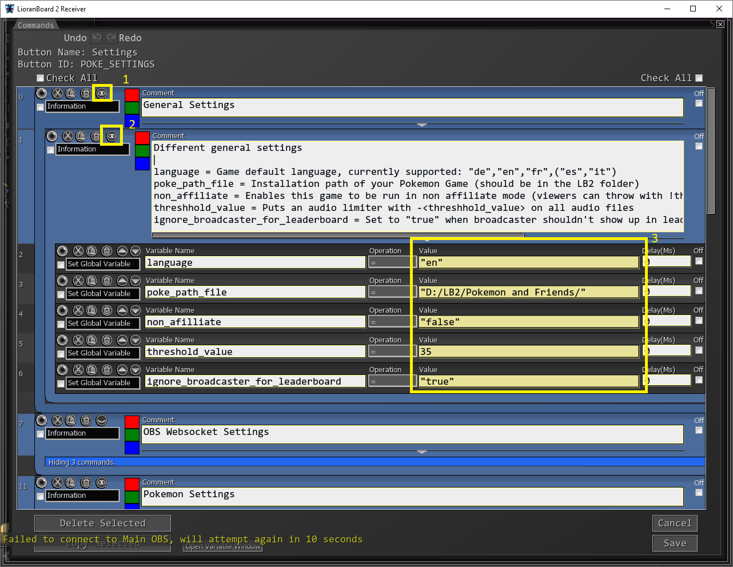

After making any changes to the settings, make sure to type **!poke-init** into your chat to load the new settings.

# Potential Fixes

## **General:**

If something is not working, please check if you have installed the newest Plugins / OBS Version / LB2 version and if not, please update it first.

## **Discord webhook not working:**

If the Pokémon screenshots are not being posted correctly, please check if you have entered the correct WebSocket Server Settings in the installer.

You can check them in OBS (“***Tools***” 🡺 “***WebSockets Server Settings***”).

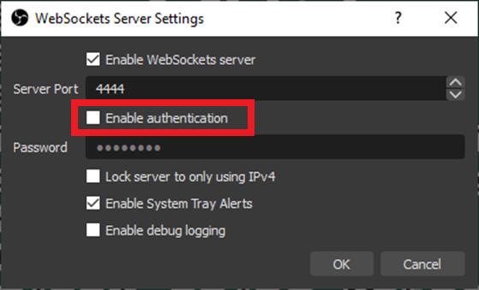

If the “***Enable authentication***” checkbox is checked, you will need to enter the correct password in the upgrader, otherwise just leave the OBS Websocket Password field empty in the upgrader.

## **Profile Pictures not working in the Catch Screenshot:**

This means that your Twitch account scopes have not been set correctly.

Please check the Lioranboard 2 Setup Guide in this manual to see how you will have to edit it.

Gifs not showing:

A few images won’t have GIFs since they don’t exist yet. In that case it automatically uses a PNG file instead. If I’m able to get these GIFs in the next version, I will swap them out.

# Special Thanks to some awesome People

[**Anni**](https://www.twitch.tv/keenepanik)- The best fiancée I could wish for

[**WaldoAndFriends**](https://www.twitch.tv/waldoandfriends) - Developing of the original Game

[**Silverlink**](https://www.twitch.tv/silverlink)- Allowing me to use parts of the code from OBSCord & The

discord webhook for LB1

**Christinna** - Allowing me to use parts of her Timer extension code

[**SiidNey**](https://www.twitch.tv/siidney)- Creating graphics and helping with a lot of feedback / bugs

[**EveraldJohnson**](https://www.twitch.tv/everaldjohnson)- Resizing all the GIFs and a lot of support

[**ShadowEnigmaTV**](https://www.twitch.tv/shadowenigmatv) - Creating more trainer graphics and the loading animation

[**MisterK**](https://www.twitch.tv/misterk_qc/)- French Translation

And of course, all the awesome beta testers!

**Credits:**

The graphics are being based on the graphics of the following sites / users:

- FurretTurret

- pkparaiso.com

- eternia.fr

- bisafans.de

# Final notes

If any problems occur during the installation, please make sure that you've followed all steps correctly and all prerequisites were installed / updated accordingly.

If the problem still persists you can get support on

[**my Discord Server (https:/discord.com/invite/gggS8AD)**](https://discord.com/invite/gggS8AD)or on the

**Streamup Discord (**[**https://discord.com/invite/RnDKRaVCEu**](https://discord.com/invite/RnDKRaVCEu)**)**

in the pokemon-and-friends-mod channel.

Thanks for downloading!



# Support me

Hey everyone,

my name is Chrizzz and I'm a C# developer that loves to create fun stuff.

This content is completely free. But if you feel like you want to leave me a tip, I would really appreciate it!

You can tip me via PayPal here:

[](https://www.paypal.com/paypalme/chrizzz1508)

<https://www.paypal.com/paypalme/chrizzz1508>

I'm also a streamer on Twitch! Please feel free to also drop by in my stream over at twitch and hang out with me.

[](https://twitch.tv/chrizzz_1508)

<https://twitch.tv/chrizzz_1508>

I would love to meet you!

Thank you for using this modified version of Pokémon and Friends!

I truly hope you love it!